

Aviation Human Factors Industry News
September 20, 2007

Vol. III. Issue 34

Phuket plane crash pilot warned of wind danger
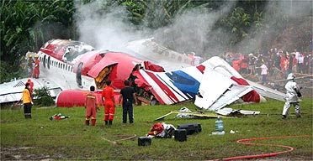
Pilot warned of wind shear but landed anyway
Pilot, co-pilot among those killed in crash

The pilot of the Thai airliner that crashed on the resort island of Phuket
was warned of a possibly dangerous wind conditions at the airport but
decided to land anyway, an aviation official has said.

The pilot and co-pilot were among the 89 people killed in the One-Two-Go
crash, which apparently took place during an aborted landing attempt. Gold
Coast father of four Brian Mullery was also killed.

Foreign Minister Alexander Downer has said it is now almost certain there
were no other Australians killed in the tragedy. Perth expatriate Robert
Borland was among those who survived and will return to Australia after
undergoing surgery for his injuries.

A transcript of the conversation between the pilot and the control tower has
revealed ground officials told the pilot that he was heading for a wind
shear - a sudden change in either wind speed or direction that can send
planes out of control.

"The last word the pilot said was 'landing'," Thailand's air transport
safety chief was quoted as saying on national television by the Associated
Press.

However an aviation expert has said it is possible the pilot was trying to
abort the landing because he could not see the runway, but the plane was
already too low.

"It was hit by wind shear or strong winds and he didn't have time to react,"
aviation writer Tom Ballantyne told AP, adding the real question might be
whether the ground officials should have allowed any attempt at landing in
such conditions.

The airline's president was earlier quoted as saying wind shear could have
caused the crash, although heavy rain on Phuket at the time may also have
contributed.

But Thailand's Trransport Minister has said it is too early to know for
sure.

"The officials have found the black boxes and will send them for analysis to
the United States," he said. "Hopefully, we will learn in a few weeks the
cause of the accident."

Safety record

This morning it was reported that South Korean authorities raised concerns
about One-Two-Go's parent company, Orient Thai Airlines, as recently as last
year.

Worries about the Thai carrier have been aired periodically as far back as
1997, when it was accused by the Thai Aviation Department of failing to keep
clear flight records and conduct six-monthly emergency training sessions for
its pilots.

In the most recent case, Orient Thai was one of three low-cost carriers from
Thailand singled out by the South Korean Ministry of Construction and
Transport in March last year for their frequent delays and sub-standard
safety measures.

The ministry found 18 safety violations across the three carriers, including
a failure by Orient Thai to update safety and operational regulation
manuals. Safety equipment, such as fire extinguishers and oxygen tanks, were
also not functioning correctly.

Orient Thai came under the scrutiny of Japanese aviation officials after a
2004 incident in which one of its jumbo jets passed within 200m of the Tokyo
Tower after it veered off course on approach to Haneda airport.

The plane was supposed to come in over Tokyo Bay but instead crossed over
Tokyo Station and the Nihombashi district, flying at an altitude of 540m.

Sunday's tragedy is Thailand's deadliest aviation accident since December
1998, when 101 people were killed after a Thai Airways plane crashed on
landing near another southern resort.

It is likely to throw the spotlight once more on Asia's rapidly growing
low-cost carriers and on Thailand's regulatory agencies.

Satellite data might have prevented jetliner crash: scientists
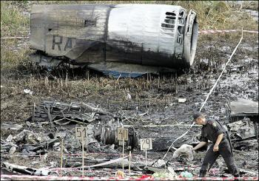
A policeman places a toy given by the relatives of a child killed in the crash of a passenger of the Russian Tupolev Tu-154 plane, at the crash site, in Sukha Balka, 40 km from the Ukrainian city of Donetsk in 2006.
TRIESTE, Italy (AFP) — The crash of a Russian jet in Ukraine last year that killed 170 people, including 45 children, might have been prevented by satellite weather software costing 1500 dollars (1200 euros), according to a study released Monday.
The software and satellite dishes providing access to data from EUMETSAT -- the European Organization for the Exploitation of Meteorological Satellites -- have since been installed in five Ukrainian cities, said Olesksiy Kryvobok, a scientist at the HydroMeteorological Institute in Kiev.
The crash helped spur that decision, he said.
In the study, Kryvobok showed that Meteostat Second Generation (MSG) images recorded in Austria an hour before the Tupolev Tu-154 plummeted to earth near
Donetck on August 22, 2006 clearly identified the violent storm cell that the plane's pilots were unable to circumvent.
Other images taken only 30 minutes earlier did not.

"It is very difficult to predict such storms," he said. "But if you use this satellite system, it is easy to detect, making it possible to warn the pilot."
Exactly what caused the crash of Pulkovo Airlines flight 612, en route from the Russian seaside resort of Anapa to Saint Petersburg, was fiercely contested in the six months following the accident.
A preliminary investigation by Russia's Emergency Situations Ministry the day after the crash suggested that it might have been struck by lighting, but officials soon backed away from that explanation.
Finally Russia's Interstate Aviation Committee concluded that the crash was due purely to human error.
The pilots, it said, showed "a lack of control over flight speed and a failure to carry out instructions on preventing the plane from stalling," also citing "unsatisfactory cooperation among the crew."
When a first attempt to circumvent the storm failed, the pilot attempted to climb over the top, taking the plane from 11,961 to 12,794 meters (39,242 to 41,975 feet) in 10 seconds. The jet stalled, and the crew was unable to recover.
Onboard storm-monitoring equipment and radar information relayed by air traffic controllers usually suffice to avoid dangerous weather patterns.
Kryvobok said his study, presented at the Fourth European Conference on Severe Storms in Trieste, did not conflict with this assessment.
But access to the MSG images would have given the pilot more time to react to the danger ahead. Storms at that altitude, he said, are "extremely rare."
Launched in 2002 and operational in 2004, MSG is a geostationary satellite, meaning that it stays at a fixed point -- somewhere along the equator -- relative to the Earth's surface at all times.
The advantage for weather forecasters is a continuous stream of images that monitor rapidly changing storm patterns at least every 15 minutes.
The development and construction of MSG-1 cost 475 million euros. But the software to run it only cost Ukraine's weather service 1500 dollars "and fit on five (USB-type) keys," said Kryvobok.
Crashes of commercial jets caused by weather alone or weather-related pilot error account for 26 percent of some 1,500 accidents in the last 50 years, according to planecrashinfo.com, a website that compiles statistics based on official inquiries.

THE NEAR MISS

Taking Advantage of Your 'Free Shot' to Fix a Safety Problem
Close only counts in horseshoes and hand grenades.
You’ve probably heard that old saying. Maybe close doesn’t count for most people. But for those of us in the world of workplace safety, close does count. A lot. The close I’m talking about is the “close call” or near miss. Let’s talk about why it’s so important and what we can do to take advantage of it.

The Significance of a Near Miss
Safety professionals in manufacturing and other industries do their best. But they’re human like everybody else. And so are the people they work with and depend on. Flawed people produced flawed programs. What that means is that every safety program has some flaw somewhere. The important thing is to figure out where the flaws are and fix them. Unfortunately, it usually takes an incident to find the flaws.
But not all incidents injure people and damage property. The incidents where nobody or nothing gets hurt are called “close calls” or “near misses.” A near miss incident is thus a “free shot” to identify and fix problems in a safety program before they do actual damage. It could be anything from someone walking in an aisle and almost getting hit by an opening door to a screwdriver being dropped to the floor by the maintenance guy working on a ladder and narrowly missing the skull of a maintenance worker below. Incidents like this happen all the time.

Why We Don’t Take Advantage of Near Misses
The problem is that near misses are the Rodney Dangerfield of the safety world. “They don’t get no respect.”
One of the reasons for this lack of respect is the tendency to confuse compliance for safety. The OSHA recordkeeping regulations require us to record and report all occupational injuries and illnesses in the workplace.

But the recordkeeping requirements don’t cover near misses. And if we don’t have to report those near misses that we see happen everywhere, we tend not to pay them any attention. No harm, no foul.
So let’s say a worker almost gets hit by a falling box. The safety director might take the following view: “Wow, that was a close one! Thankfully, there was no injury, no first aid, no lost or restricted time. I almost had a boatload of paperwork, investigation, corrective action and training to do on that one.”

Respect the Near Miss
Of course, that is a terrible mistake. The truth is that neglect of near misses is a missed opportunity for prevention and a recipe for future accidents. The fact that nobody got hurt or no machinery got damaged was an accident. What’s important to realize is that something went wrong and it could go wrong again. So you need to fix the problem because the next time you might not be so lucky. And you need to be grateful the near miss happened because it gave you the chance to prevent an injury.

Doing Something about Near Misses
You may say that there’s no way to address near misses since you don’t know when they occur. After all, you can’t be everywhere to see them happen. And you can’t necessarily count on workers to report them.
Not knowing about near misses is a real problem. I’m not so naive to believe that all of the near misses that happen on the shop floor will get recognized and reported. But there are steps you can take to make it more likely for near misses to get reported. Establishing a safety conscious attitude throughout the company and explaining the importance of near misses will go a long way toward getting people on the floor to recognize and report them.
I know that that’s easier said than done and that for many of us this may be the biggest challenge in establishing an effective safety program. This is especially true if your plant has that sports locker room code of “what happens in the shop stays in the shop.” But this is where the safety director can really make a difference. A good safety director can change that mentality. So there’s your challenge: Go out and create that work environment atmosphere that has workers thinking safety every day, be visible, accessible, active and relentless; listen to your workers and use everyone as a resource.

Conclusion
The next time you get a call from one of your supervisors, foremen, lead persons or operators on the shop floor asking you to come and look at a potential problem, don’t think – great, here comes a load of $*#^$%#@!! paperwork.

Instead, think– hey, my safety program is working. They’re telling me about a problem and giving me a chance to fix it before it does real damage. If they’re doing something right, I must be doing something right. And, if we’re all doing something right, we must be on our way to a safer and healthier workplace.
Boeing's McNerney Says Fastener Shortage To Blame For 787 Delays

Points Finger at Alcoa, Others


A plane can't fly if it's in pieces... and Boeing is facing a dearth of permanent fasteners for its first 787. That's the word from Boeing CEO Jim McNerney, who pointed his finger at Alcoa Inc. and others lastTuesday as reasons why the company had to postpone the first flight of the composite-bodied Dreamliner.

"The supply chain is just gradually catching up," McNerney told investors during a teleconference, according to Reuters. "We are making progress -- it's still a scramble though, if I'm honest."

As ANN reported, Boeing announced last week the first 787 test flight would be postponed until mid-November -- or even later -- due to problems with assembly, and flight software systems integration. A shortage of permanent fasteners to hold segments of the plane's composite barrel-section fuselage is considered the main problem facing Boeing, however.

Suppliers may not be entirely to blame for the shortage... as the industry as a whole is still struggling to return to pre-9/11 production levels. Boeing wasn't

caught unaware of a problem, either... as the planemaker said in March a shortage of the critical parts was looming.

McNerney conceded many didn't anticipate the growth seen in the commercial airliner market over the past few years. He did imply, however, that many companies could have done a better job of ramping up their operations.

"You know the root cause here -- the fastener industry got consolidated, post 9/11," said McNerney. "The consolidators misjudged the demand swingback -- a lot of us misjudged the demand swingback -- post 9/11."

Alcoa is the main supplier of aluminum and titanium fasteners for the 787; the planemaker hasn't publicly identified other companies, if any, supplying those parts for the program.

A spokesman for Alcoa says the company is doing all it can to catch up. "We are working with them (Boeing) to try to get them as many fasteners as we possibly can for this program," said Kevin Lowery.

"Every day we are getting them more and more -- we are making great progress."

Boeing used temporary fasteners to assemble the first 787 in time to unveil during a July 8 ceremony. The aircraft was little more than an empty shell at that point, lacking many internal systems. Engineers are still working at pulling out those temp bolts, and replacing them with permanent fasteners.

"We have a lot of temporary fasteners in that first airplane, that are now being reworked," McNerney said. "The supply chain is just gradually catching up."

He defended Boeing's assertion that despite the delay in first flight -- termed a "stutter-step" by McNerney -- the planemaker will still be able to fully test and certify the Dreamliner in time for its planned May 2008 entry-into-service with All Nippon Airways.

"It's an aggressive plan, but it has substance to it," he said.

Bombardier Urges Airlines to Ground Q400 Turboprops


Bombardier Inc., the world's third- biggest aircraft maker, urged airlines to ground 60 of its Q400 turboprops after a second landing-gear failure in a week.
All Q400s with more than 10,000 cycles -- comprising a takeoff and landing -- should be grounded until they're inspected, Montreal-based

Bombardier said today. The landing gear was made by Goodrich Corp. of the U.S., it said.
The twin-engine Q400 has had some ``teething problems,'' said Cameron Doerksen, an aviation analyst at Versant Partners in Montreal. ``This is clearly some bad press, but I don't think it will impact an airline's decision to buy the plane.'' Doerksen rates Bombardier as a ``buy.''
The grounding recommendation covers Q400s flown by carriers including Scandinavian Airlines, Alaska Air Group Inc.'s Horizon Air unit, the U.K.'s Flybe, Japan Airlines Corp., Austrian Airlines Group and Germany's Augsburg Airways.
Both accidents occurred in Europe, and neither involved fatalities. Bombardier ``cannot speculate or comment as to the cause of these incidents'' until the investigations are complete, the planemaker said. Bombardier said it sent a company air-safety expert to Europe.
``About 60'' of the more than 160 Q400s delivered so far have exceeded the 10,000-cycle threshold, Bombardier said. Spokesman Marc Duchesne said the Q400 entered service in early 2000. The Q400 carries as many as 78 passengers.
`Precautionary Measure'
Recommending the grounding of the planes was ``a precautionary measure,'' said Bombardier, which issued the statement with Charlotte, North Carolina-based Goodrich, the world's largest supplier of aircraft landing gear.
Goodrich has dispatched a team to Europe to assist Bombardier and local authorities, spokeswoman Lisa Bottle said in an e-mail.
The most recent accident occurred when part of the landing gear on a Scandinavian Airlines Q400 collapsed last week after landing in Vilnius, Lithuania, Bombardier said in a statement.
Flight SK2748 from Copenhagen to Palanga, Lithuania, experienced difficulties en route and was diverted to Vilnius, airline parent SAS Group said in a statement. All 48 passengers and four crew members were evacuated, with no injuries reported, Stockholm-based SAS said.
On Sept. 9, a Scandinavian Airlines Q400 caught fire in Aalborg, Denmark, after its landing gear failed to work. In the Sept. 9 accident, five of 69 passengers were injured.
CAL finishes inspection of its 13 Boeing aircraft
NUTS AND BOLTS: A CAL official said that nearly half of the nuts examined were below standard, but added that it was not necessarily a factor behind the Naha incident
China Airlines (CAL) said yesterday it had completed examinations on the slat track downstop assemblies on all of its 13 Boeing 737-800 planes on Friday.
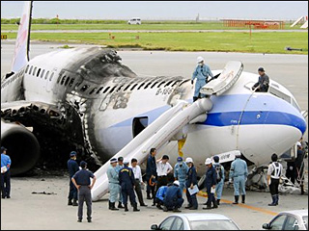
The examination was one of the requirements listed in the emergency directive issued by the US' Federal Aviation Administration on Aug. 28 asking airlines worldwide to carry out the examination within 10 days upon receipt of the notice. Friday was the last day.
Steve Yuen (阮祥運), vice president of CAL's engineering and maintenance department, said each Boeing 737-800 has 16 slat track downstop assemblies. In total, CAL has checked 208 nuts on the assemblies and found 100 of them were below the standard torsion value.
The standard torsion value, as indicated in the directive, should be between 50 inches-lb and 80 inches-lb, but the majority of those found below standard had only 40 inches-lb.
Yuen said this was simply an issue they found during the examination and was not necessarily the cause of the aircraft blast at Naha Airport in Japan last month.
The inspection team also found some of the components on the assemblies were not placed in accordance with the Boeing aircraft maintenance manual.
However, Yuen said that the company's maintenance crew rarely tamper with the assemblies.
He said the crew started paying attention to the nuts on the slat track downstop assemblies only after Boeing Co issued a service letter in March last year indicating that two fuel leak incidents were reported to have been caused by loose nuts on one of the assemblies. Boeing further "suggested" that the nuts be changed.
Yuen pointed to a fleet team digest published on Aug. 23 last year, saying the loose nuts could cause a "streaming fuel leak."
CAL has changed five nuts on the assemblies following the issuance of the notice, including one on the aircraft destroyed in the Naha incident.
Yuen said that CAL would submit the inspection results to the Civil Aeronautics Administration tomorrow.

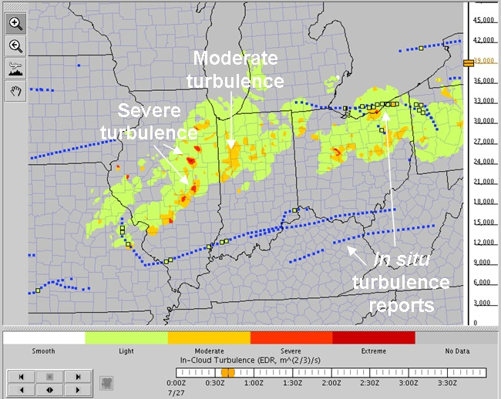
New System Helps Airliners Avoid Turbulence
Airplane passengers could soon experience much less in-flight turbulence if testing goes well for a new detection system designed to end stomach-lurching bumpy rides and reduce delays.
The air turbulence detection system , designed by the National Center for Atmospheric Research (NCAR), has already successfully alerted some pilots steering United Airlines commercial flights to patches of rough air as they flew through clouds.
"We hope this will provide a significant boost to the aviation industry in terms of passenger comfort, safety and reduced costs," said NCAR scientist John Williams.
The system uses a mathematical method known as the NEXRAD Turbulence Detection Algorithm, or NTDA, to analyze data obtained from the National Weather Service's network of Next-Generation Doppler Radars (NEXRAD). NTDA detects turbulence in storms by peering into clouds and analyzing the distribution of winds inside. It reprocesses the radar data to remove contaminating factors, such as sunlight, nearby storms or even swarms of insects flying near the radar dish.
The data are compiled into real-time snapshots, or "nowcasts," of turbulence and transmitted to pilots in the cockpit and made available to airline meteorologists and dispatchers via a Web-based display.
Reducing flight delays
THE NTDA system is being tested through October by a group of United Airlines pilots who fly routes east of the Rockies, where air turbulence is a major problem.

Captain Rocky Stone, chief technical pilot for United Airlines, says he is impressed by the system. "The messages I've received in the cockpit gave a very accurate picture of turbulence location and intensity," Stone said. "The depiction of turbulence intensity provides an unprecedented and extremely valuable new tool for pilot situational awareness."
If results from this year's test remain promising, the system could be expanded to additional United aircraft or other airlines. Williams anticipates that by 2011, NTDA will be used across the contiguous United States to provide turbulence reports updated every 15 minutes.
Developers say NTDA could help reduce flight delays by allowing pilots to avoid only those thunderstorms they deem a turbulence threat. "Current FAA guidelines suggest that pilots avoid thunderstorms by a wide margin," Williams explained. "By giving more specific information on the location and intensity of turbulence, we expect that the in-cloud NTDA product will reduce unnecessary deviations and the resulting delays, while also providing increased safety and passenger comfort."
A societal benefit
Air turbulence is a major problem for airlines. According to a review of National Traffic Safety Board data from 1992 to 2001 by the National Aviation Safety Data Analysis Center, turbulence was a factor in at least 509 accidents in the United States that resulted in 251 deaths in general aviation flights, which do not typically include large commercial aircraft. Additionally, the FAA estimates that there are more than 1,000 minor turbulence-related injuries on commercial aircraft annually.
"We expect that our new in-cloud turbulence detection system will be able to mitigate at least a fraction of that cost, producing a significant societal benefit," Williams told LiveScience.
The new system could also do away with the annoyance of repeated in-flight buckling and un-buckling of seat belts, Williams said. "One benefit of our system is that when a pilot uses it to turn on the 'fasten seat belt' sign, the passengers and crew can be confident that there really is turbulence ahead," Williams said.

The research is funded by the Federal Aviation Administration (FAA) in partnership with the National Science Foundation.

Airline sacrifices goats to appease sky god

Nepal's state-run carrier makes offering after technical problems with 757

KATHMANDU - Officials at Nepal's state-run airline have sacrificed two goats to appease Akash Bhairab, the Hindu sky god, following technical problems with one of its Boeing 757 aircraft, the carrier said Tuesday.
Nepal Airlines, which has two Boeing aircraft, has had to suspend some services in recent weeks due to the problem.
The goats were sacrificed in front of the troublesome aircraft Sunday at Nepal's only international airport in Kathmandu in accordance with Hindu traditions, an official said.
"The snag in the plane has now been fixed and the aircraft has resumed its flights," said Raju K.C., a senior airline official, without explaining what the problem had been.
Local media last week blamed the company's woes on an electrical fault. The carrier runs international flights to five cities in Asia.
It is common in Nepal to sacrifice animals like goats and buffaloes to appease different Hindu deities.

Eclipse 500s to enter air taxi fleet service

Air Taxi fleets are the biggest customers of Eclipse, and two providers are about to be the first to put their new jets into service.

Massachusetts-based Linear Air is set for a "mid-September" first flight of its lone Eclipse 500. Three more will join the active fleet of Cessna Grand Caravans by year's end.

"The fact is, this VLJ and the additional fleet we've ordered will make a seamless transition into our current business model allowing customers immediate access to cutting-edge aviation," said Bill Herp, Linear Air chief executive.

Florida-based DayJet announced on 5 September that the FAA has approved its use of Eclipse 500s, and chief executive Ed Iacobucci expects to launch service around 12 September. He says putting the new Eclipse on DayJet's certificate called for more proving runs than other craft would require. The service could launch immediately, but DayJet will be running more simulations and inspecting operations before opening its online reservation system.

"We'll watch those carefully and make sure we didn't miss something," Iacobucci says.

He adds that initial service will not be for every member. Certain client companies will be invited in so that the complex computer programs that run scheduling, routes and maintenance can be tested. "But I'm talking only a few days," he says.
Nearly 180 of the 350 employees he plans to hire by the end of the year are on board, and 12 of the 310 Eclipses on order have arrived. Four or five will be in service initially, he says. "We've got four that I'm dedicating to training, because we still don't have the simulators, of course."

DayJet expects eight more Eclipses by mid-October, with Avio NG integrated cockpits installed. The current fleet should be retrofitted by winter, Iacobucci says. "We're still flying the old fashioned way," he says. "Radar would be nice. LNAV would be nice. I know flight into known icing is one of the things that

Eclipse chief executive Vern Raburn has high on his list right now."

Drowsy Driving

Midnight Shift Nugget

Sleep Difficulties and Insomnia: A Practical Guide

On average, we need about seven to eight hours of sleep a night to function optimally. In today's fast paced and high stress society, a third of the population reports difficulties with sleep, and about 10% of people report chronic insomnia, a condition that involves trouble falling or staying asleep, waking up in the middle of the night or too early in the morning, persistently poor sleep quality, and trouble functioning the next day.
There are many reasons why people have trouble sleeping. High levels of stress, anxiety, and/or depression are often the culprit. Other possible causes include medical problems or conditions, chronic pain, use of certain medications, excessive use of alcohol, nicotine, or caffeine, or the presence of a more complicated sleep disorder (such as sleep apnea or restless leg syndrome).
In order to address sleep difficulties, it is important to identify the specific cause. It is wise to consult with your family physician to rule out medical problems that could be causing poor sleep.
If sleep problems are caused by depression, anxiety, or high levels of stress, consulting with a psychologist is a good idea, as psychological treatments such as cognitive-behavioral therapy have been shown to very effective at decreasing anxiety and depression and helping people to improve how they cope with stress. Certain medications that target anxiety and depression can also be prescribed by your physician. If an underlying depression or anxiety disorder is properly treated, sleep problems often improve.

Sometimes people have sleep problems or insomnia in the absence of any other psychological difficulties such as depression or anxiety. In these cases, seeing a psychologist can still be very helpful, as certain psychological interventions have been shown to be effective at addressing poor sleep directly.
Psychologists can teach you to learn to relax, cope with stress, and improve your "sleep hygiene" (or habits). Psychologists can also use other behavioral strategies to help target sleeping problems. About 75% of people with insomnia report significantly improved sleep after undergoing such psychological treatment.
Family physicians often prescribe hypnotic medications that help people to sleep. These medications are often helpful for individuals who are going through a stressful period. It is advised to only use these medications in the short-term as they can become addictive and less effective if you use them nightly over longer periods of time. Moreover, some of these medications can result in drowsiness and concentration difficulties the following day. Over the counter sleep supplements have generally been found to be ineffective.
As a general rule, sleeping medication can be helpful in the short-term but becomes less effective over time, whereas psychological treatments are effective in the long-term.
Human Interest Story

Still soaring to new highs

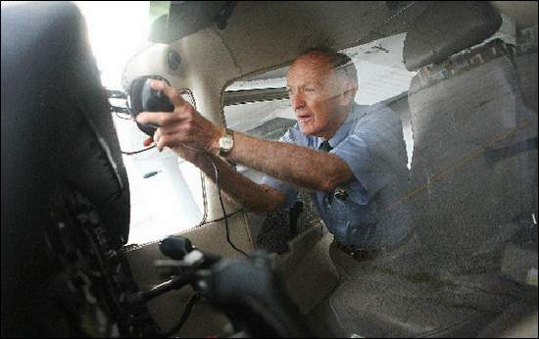
FAA recognizes contributions of 80-year-old flight instructor

John Dougherty, 80, of Irondequoit prepares a Cessna 172SP before a flight with a student at the Rochester Air Center in Chili.

The longtime instructor received the Wright Brothers Master Pilot Award from the FAA.
John Dougherty turned 80 in June, but the Irondequoit resident has no plans to retire. He lives on his own, cooks his meals and drives himself to take care of his errands.
And five days a week, he's thousands of feet in the air giving flight instruction to student pilots.
Dougherty was recently presented the Wright Brothers Master Pilot Award by the FAA. The designation recognizes pilots who have contributed to building and maintaining aviation through safe flight of more than 50 consecutive years.
"I have no accidents, no incidents, no violations," Dougherty said.
Known as a man of few words, Dougherty is hard-pressed to come up with the number of students he's helped train since beginning flight instructing in the 1960s.
"Hundreds," he estimates.
"Although he's certainly trained a lot of pilots, his specialty has been training flight instructors," said Guido Hassig, a safety inspector with the FAA office in Rochester. "These are many of the folks that go on to have careers in aviation."
Now the chief flight instructor at the Rochester Air Center on Scottsville Road in Chili, Dougherty first took to the skies when he was 12.
"My parents took me up on an introductory flight," he said. "I enjoyed it."
When he was 17, he served in the Marines during World War II, but was too young to become a pilot. After the war, he worked as a financial controller for a research organization. It was then he decided to become a pilot.
"I just liked it," he said. "I like the adventure of it."
Since his solo on July 12, 1952, Dougherty has racked up more than 14,000 hours of flight time as well as an advanced ground instructor certificate and an airline transport pilot certificate.
Less experienced pilots often seek Dougherty's guidance.
"I go to him with any sort of question I have," said Steven Stanwix, 28, another flight instructor at the center. "He has all the rules and regulations memorized."
Dougherty's Marine background suits his no-nonsense, straightforward persona. He says he can't pick a favorite flight or flying memory.
But Hassig and others who know Dougherty say he's got a dark sense of humor.
"It's not easy to get (anything) out of him," Hassig said.
Dougherty says he doesn't have many hobbies, but he exercises regularly.
"That's how I keep healthy," he said.
Like other pilots, Dougherty must be physically certified to maintain his pilot certificate. Blood pressure, eyesight and reflexes are among the items checked each year.
"He will not retire," said fellow flight instructor Bob Barrett. "Flying is his life."

EMERGENCY PREPAREDNESS

For College Students
September is also Campus Fire Safety Month in many states. So it’s an appropriate time to ask: When your son or daughter went off to college this fall, did he or she find a safe place to live?
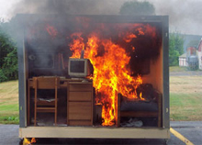
Add Fire Safety 101 to Your Studies
Big old houses near a campus are traditional accommodation for many university students. Formerly single-family dwellings, some of these buildings were first converted to student housing a half-century ago. They may have been adequate at the time, when the average student arrived with an electric radio and a manual typewriter. Today’s student typically hauls in an array of electronic devices—computer, printer, television, video player, game gadgets, microwave and hair dryer. And typically, the houses have not been updated with wiring to handle this electrical demand.
Besides outdated and inadequate wiring, a historic house might also lack fire protection equipment such as alarms and escape stairs. Early-day insulation and wall coverings may burn more easily than today’s building materials. In addition, security and good lighting may be lacking. Maybe you should have a look at your child’s new home. If it is not safe, consider helping with a move to better quarters.
Other ways to assist would be installation of smoke detectors, fire extinguishers, portable escape ladders and security bars.
The NFPA provides valuable information on how to address fire risks associated with student housing. You can also share this emergency planning checklist with your son or daughter.

Picture This!

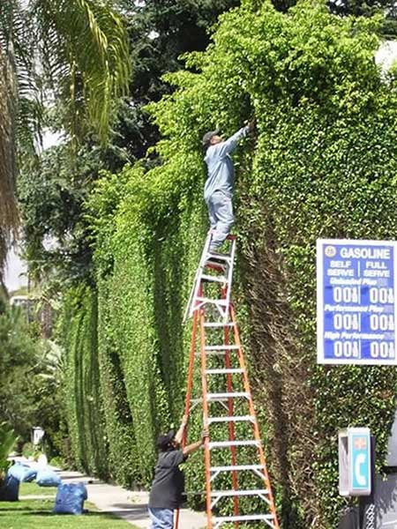

END

